CLASS 1

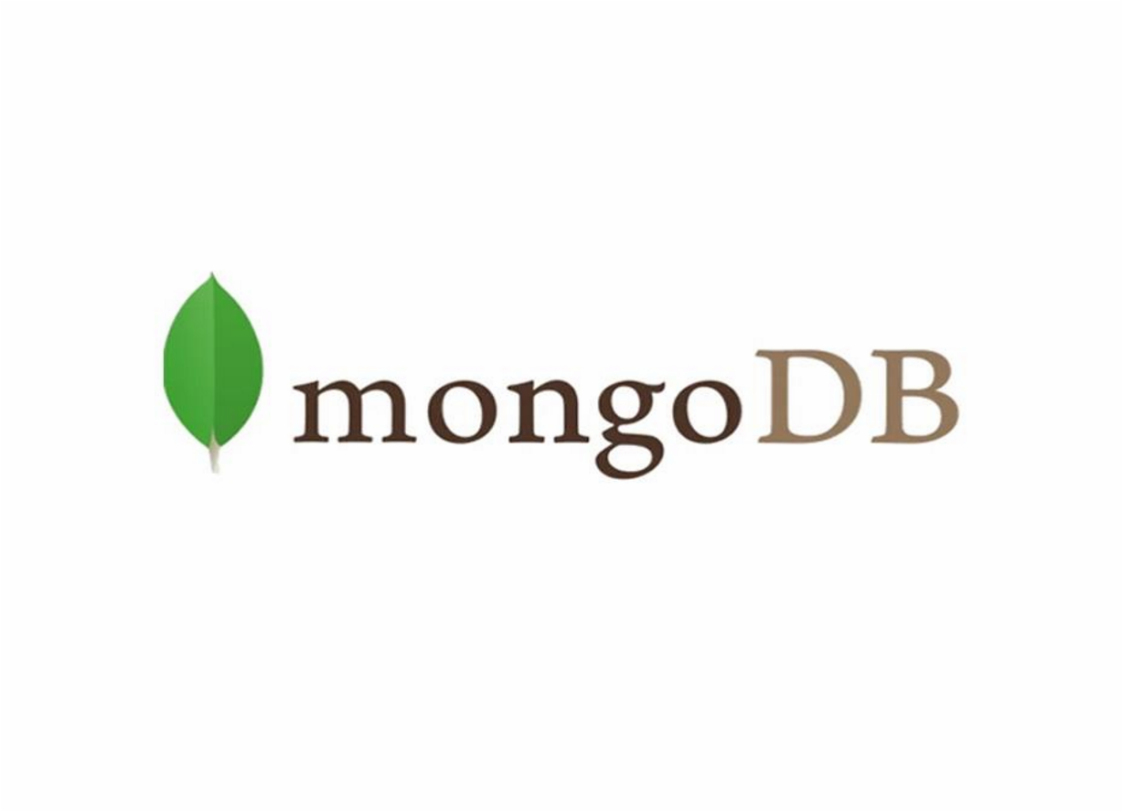

**MongoDB** : Introduction

The most popular NoSQL database, is an open-source document-oriented database. The term ‘NoSQL’ means ‘non-relational’. It means that MongoDB isn’t based on the table-like relational database structure but provides an altogether different mechanism for storage and retrieval of data. This format of storage is called BSON ( similar to JSON format).

**A simple MongoDB document Structure:**

|  |
| --- |
| { title: 'Geeksforgeeks', by: 'Harshit Gupta',  url: 'https://www.geeksforgeeks.org', type: 'NoSQL'  } |

**Data Base**

Database is a physical container for collections. Each database gets its own set of files on the file system. A single MongoDB server typically has multiple databases.

**Data Types**

Databases can hold various kinds of information, including text, numbers, images, videos, and more.

# Advantages of Using MongoDB:

* **Development Speed:**
* MongoDB's flexible data model allows developers to iterate quickly, adding and modifying fields without downtime. - **Horizontal Scalability:**
* MongoDB's sharding capability ensures that applications can scale out by adding more servers to handle increasing loads.

## Features of MongoDB:

* **Document Oriented**: MongoDB stores the main subject in the minimal number of documents and not by breaking it up into multiple relational structures like RDBMS. For example, it stores all the information of a computer in a single document called Computer and not in distinct relational structures like CPU, RAM, Hard disk, etc.
* **Indexing**: Without indexing, a database would have to scan every document of a collection to select those that match the query which would be inefficient. So, for efficient searching Indexing is a must and MongoDB uses it to process huge volumes of data in very less time.
* **Scalability**: MongoDB scales horizontally using sharding (partitioning data across various servers). Data is partitioned into data chunks using the shard key, and these data chunks are evenly distributed across shards that reside across many physical servers. Also, new machines can be added to a running database.
* **Replication and High Availability**: MongoDB increases the data availability with multiple copies of data on different servers. By providing redundancy, it protects the database from hardware failures. If one server goes down, the data can be retrieved easily from other active servers which also had the data stored on them.
* **Aggregation**: Aggregation operations process data records and return the computed results. It is similar to the GROUPBY clause in SQL. A few aggregation expressions are sum, avg, min, max, etc.

## Where do we use MongoDB?

MongoDB is preferred over RDBMS in the following scenarios:

* **Big Data**: If you have huge amount of data to be stored in tables, think of MongoDB before RDBMS databases. MongoDB has built-in solution for partitioning and sharding your database.
* **Unstable Schema**: Adding a new column in RDBMS is hard whereas MongoDB is schema-less. Adding a new field does not effect old documents and will be very easy.
* **Distributed data** Since multiple copies of data are stored across different servers, recovery of data is instant and safe even if there is a hardware failure.

## Language Support by MongoDB:

• MongoDB currently provides official driver support for all popular programming languages like C, C++, Rust, C#, Java, Node.js, Perl, PHP, Python, Ruby, Scala, Go, and Erlang.

# • Mongodb Insallation Process

* <https://www.geeksforgeeks.org/how-to-install-mongodb-on-windows/>

* **Mongodb Shell**

* <https://www.mongodb.com/docs/mongodb-shell/install/#install-mongosh>